Name: Trần Nguyễn Quang Vinh

Student Code: SE184691

**Subject: PRF192- PFC**

**Workshop 01 – Report**

**Objectives:**

1. Exploring memory of a C program
2. Using data input and output functions

**EX1: Explore memory structure of programs (2 marks)**

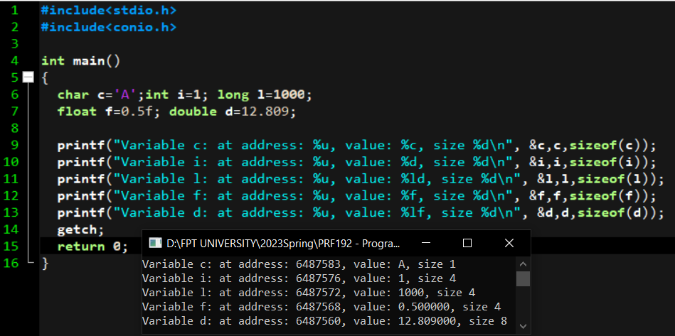

**EX2: Using data input and output functions (4 marks)**

* Write a C program to input length and width of a rectangle and calculate perimeter of the rectangle.

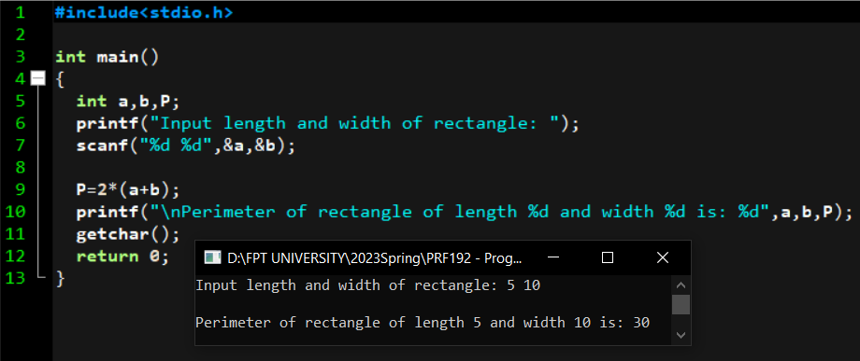

**EX3: Using data input and output functions (4 marks)**

* Write a C program to input radius of a circle from user and find diameter, circumference and area of the circle.

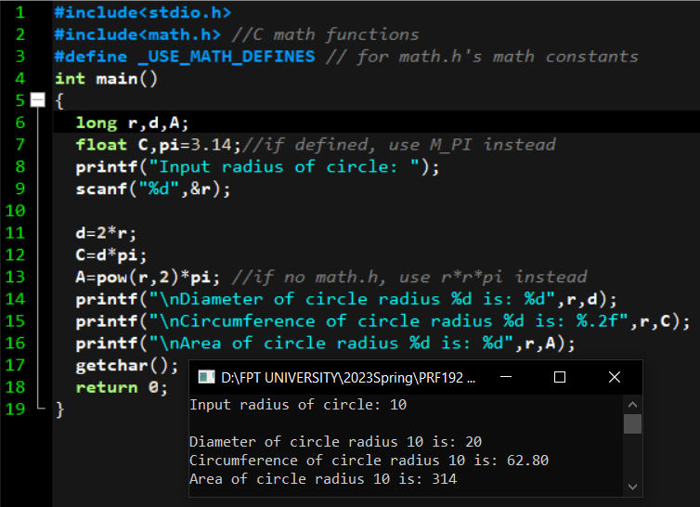

pow(r,2) is a math.h functions, pow(r,2) = r2